3

a)

Consider $H\left(z\right)=\frac{1}{1-αz^{-1}}$, the impulse response coefficients are $H\left[n\right]=α^{n}$ ($n>0$). And $H_{2}\left(z\right)=\frac{1}{1+αz^{-1}}=\frac{1}{1-(-α)z^{-1}}$, we use $–α$ take the place of $α$ and get $H\left[n\right]={(-α)}^{n}$ ($n>0$). In order to get z transform, we need | | 1.

The frequency response $H_{2}\left(e^{jw}\right)=\frac{1}{1+αe^{jw}}=\frac{1+αcosω-jαsinω}{1+2αcosω+α^{2}}.$

b)

Now $H\left(z\right)=\frac{1}{1+αz^{-8}}$. Assume $α=0.5, we get$

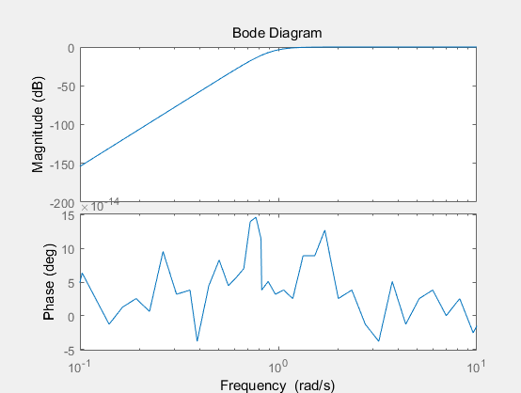

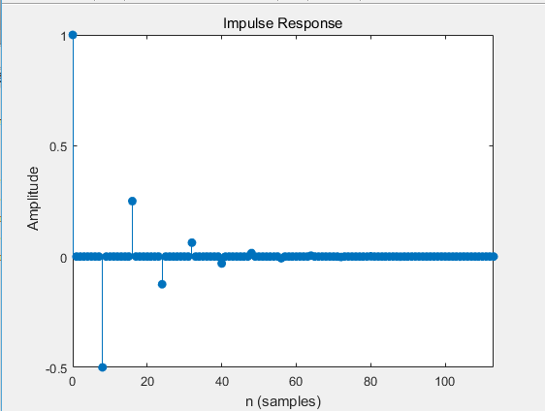

Matlab codes:

num=[1 0 0 0 0 0 0 0 0];

den=[1 0 0 0 0 0 0 0 0.5];

bode(num,den);

impz(num,den);

4

a)

$$H_{3}\left(e^{jw}\right)=\frac{e^{-jw}-α}{1-αe^{jw}}=\frac{-α+cosω-jsinω}{1-α(cosω-jsinω)}=(cosω-jsinω-α)∙\frac{1-αcosω-jαsinω}{1-2αcosω+α^{2}}$$

$$H_{3}{\left|e^{jw} \right|}^{2}={(cos}^{2}ω+\sin^{2}ω+α^{2}-2αcosω)∙\frac{1}{1-2αcosω+α^{2}}$$

$$H_{3}{\left|e^{jw} \right|}^{2}=\left(1-2αcosω+α^{2}\right)∙\frac{1}{1-2αcosω+α^{2}}=1$$

b)

$$H_{3}\left(e^{jw}\right)=\frac{e^{-jw}-α}{1-αe^{jw}}=\frac{e^{-jw}}{1-αe^{jw}}-\frac{α}{1-αe^{jw}}$$

$$H_{3}\left(e^{jw}\right)=e^{-jw}∙\frac{1}{1-αe^{jw}}-α∙\frac{1}{1-αe^{jw}}$$

$$H\left[n\right]=F^{-1}\left(e^{-jw}∙\frac{1}{1-αe^{jw}}\right)-{α∙F}^{-1}\left(\frac{1}{1-αe^{jw}}\right)$$

$$H\left[n\right]=α^{n-1}-α∙α^{n}=\left(1-α^{2}\right)∙α^{n-1} (n>0)$$

When $(n<0)$, we can easily get $H\left[n\right]=0$

c)

Now $H\left(z\right)=\frac{z^{-8}-α}{1-αz^{-8}}$. Assume $α=0.5, we get$

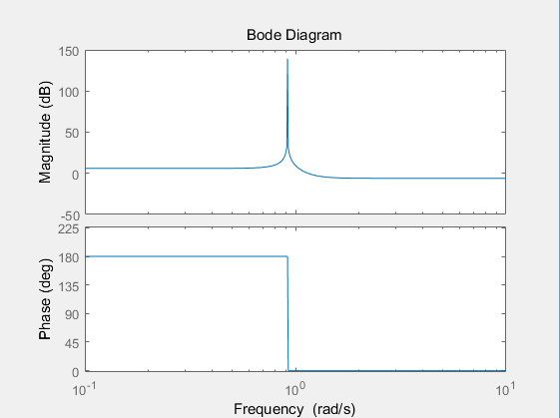

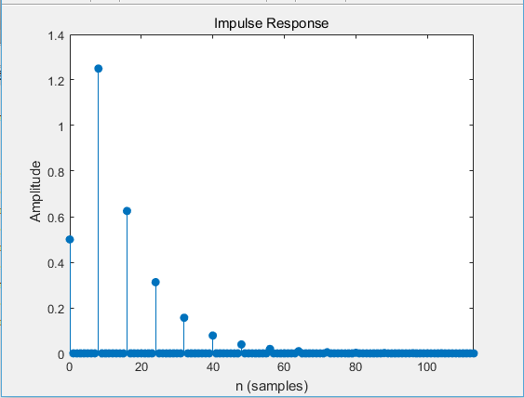

Matlab codes:

num=[0.5 0 0 0 0 0 0 0 1];

den=[1 0 0 0 0 0 0 0 -0.5];

bode(num,den);

impz(num,den);